Lesson 1 - BIM Terminology & Acronyms
Lesson 1 of 4

Lesson Objectives
In this lesson we aim to:
Introduce BIM by defining the term and considering how it is used.
Understand how the term BIM is used in many different ways by many different people.
⧉ Audio placeholder (00:08) — no local audio matched this placeholder

What is Building Information Modeling (BIM)?
"Use of a shared digital representation of a built object to facilitate design, construction and operation processes to form a reliable basis for decisions."(This is the definition from the IS0 19650-1)

BIM Terminology and Acronyms
In the BIM world there are many acronyms!

The Contractual Tree
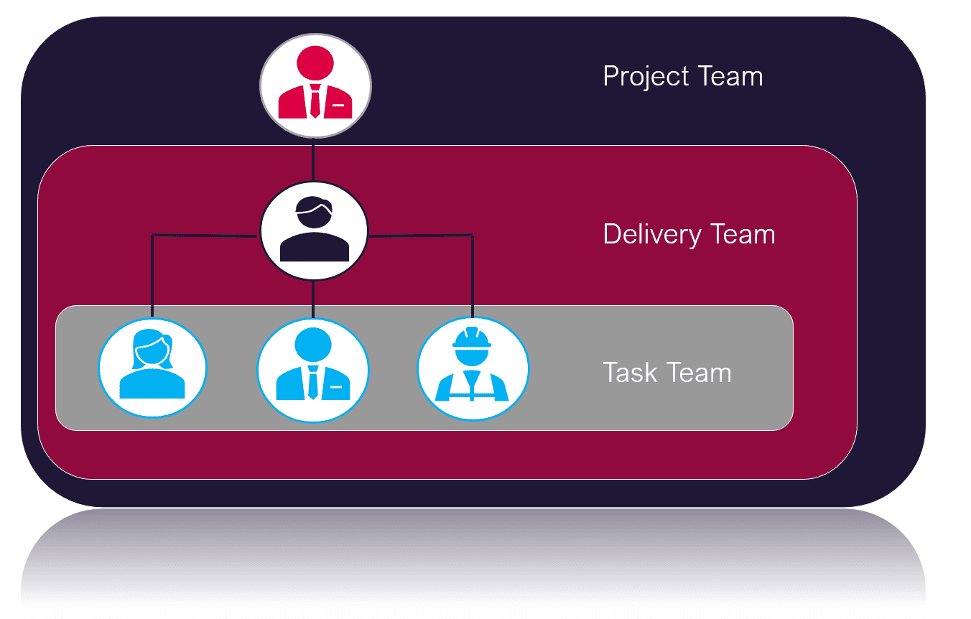
Audio transcript (00:51)
There is different terminology in ISO 9650 in relation to certain types of teams. This relates to a kind of contractual or project organisational tree as shown here. Here you will see the three parties according to ISO 9650 and how they're structured within project delivery and task teams. At the top of the tree we can see the client who is referred to as the appointing party. Below this are the lead designer or contractor who are referred to as the lead appointed party. There can be more than one lead appointed party it is worth noting and lastly below this are the appointed parties of which there is typically several. Appointing party, lead appointed party and appointed party will form the project team. The lead appointed party and appointed party should be the delivery team and the appointed parties will form the task team.
Source audio: Lesson 1 - BIM Terminology Acronyms - BIM ISO 19650 12 Project D.mp3

You may be wondering what or who an appointing party may be and how this differs from what you may have traditionally referred to as a client or an employer…

Client V Employer

Flashcards
Client
The person or organization responsible for:
- Initiating and financing a project
- Approving the brief
This person may be the building owner
Employer
The person or organization entering into the contract for:
- Goods
- Services or
- Engineering / Construction works
The Appointing Party encompasses both of these, Client and Employer.
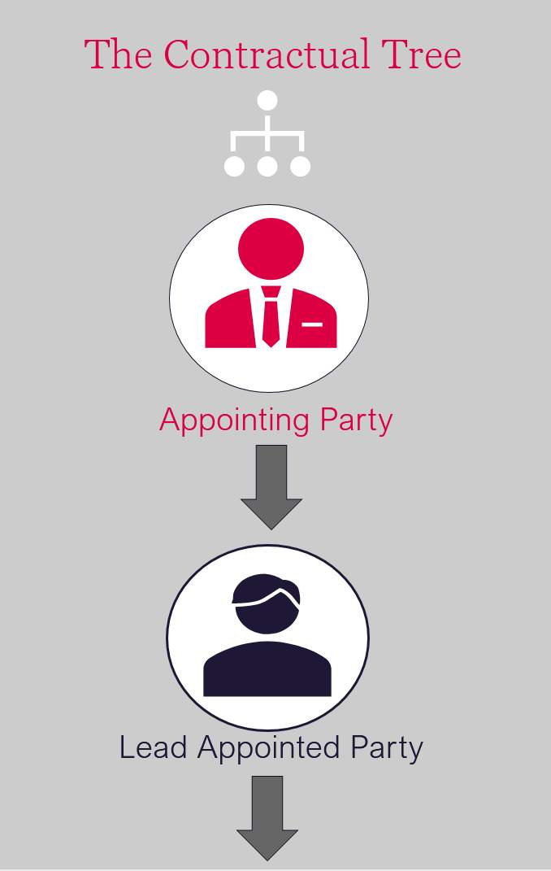
⧉ Audio placeholder (00:25) — no local audio matched this placeholder
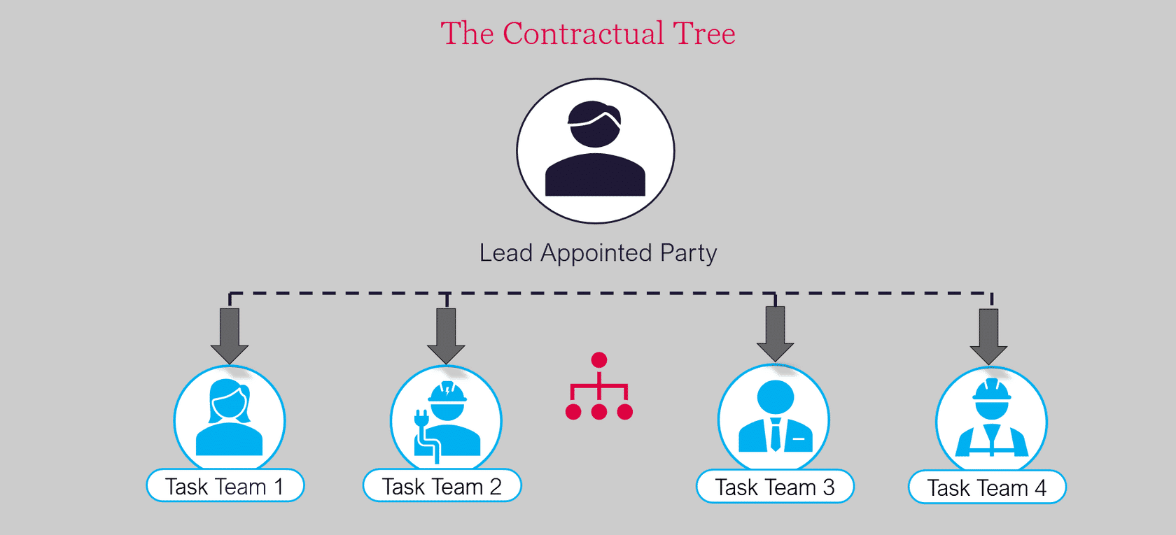
Audio transcript (00:57)
The lead appointed party then appoints a series of subcontractors known as appointed parties and so forming the delivery team or teams. The lead supplier, having now appointed the task teams, has also become an employer. The appointing party appoints a delivery team which is led by a lead appointed party. The lead appointed party will then have a number of task teams producing deliverables. The need is communicated down through the appointments, including the EIRs. Then the required deliverables are communicated up. Further terminology includes appointments, these are agreed instructions for the provision of information concerning works, goods or services. Appointing party, this is the receiver of information concerning works, goods or services from a lead appointed party. Lead appointed party and task teams, these are the providers of information concerning works, goods or services.
Source audio: Lesson 1 - BIM Terminology Acronyms - BIM ISO 19650 12 Project D (1).mp3

BIM Terminology: Teams
During the course we reference the different team and stakeholder terminologies. There are three team categories that exist:
- Project Team
All parties involved in the delivery of information process. The appointing party, lead appointed party and all appointed parties.
- Delivery Team
The multiple stakeholders responsible for creating the information, typically the lead appointed party and their appointed parties
- Task Team
The person or team contained within the delivery team that are deemed responsible for a specific task or information requirement, such as an Architect providing a drawing package.

BIM Terminology: Appointing Party
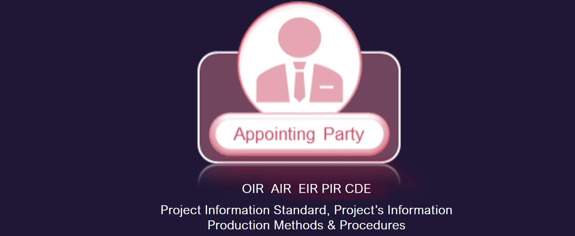
Shown here are the most common BIM terms , abbreviations and documents used in relation to Appointing Party Responsibilities:
OIR AIR EIR PIR PIS PIPMP CDE COBIe
We shall discuss what these mean next...

Flashcards
Card 1
OIR: Organizational Information Requirements.
What information the Employer’s Organization needs.
Card 2
AIR: Asset Information Requirements.
What information the asset management team needs manage the asset.
Card 3
EIR: Exchange Information Requirements.
What information an Employer needs and its acceptance criteria.
Card 4
PIR: Project’s Information Requirements.
These are expressions of the high-level information needed by the client to make key decisions concerning the project. This can use the Plain language Questions technique, a technique to produce non-technical questions which can be used as information requirements.
Card 5
Project’s Information Standard
The structure, classification and standards relating to the exchange of information.
Card 6
Project’s Information Production Methods & Procedures
Establish the procedures for the generation, review, approval and distribution of new information to the Appointing Party.
Card 7
CDE: Common Data Environment.
A process to manage and exchange files in a collaborative environment.
COBIe
Construction Operations Buildings information exchange.
A defined schema to exchange asset information.

BIM Terminology: Delivery Teams
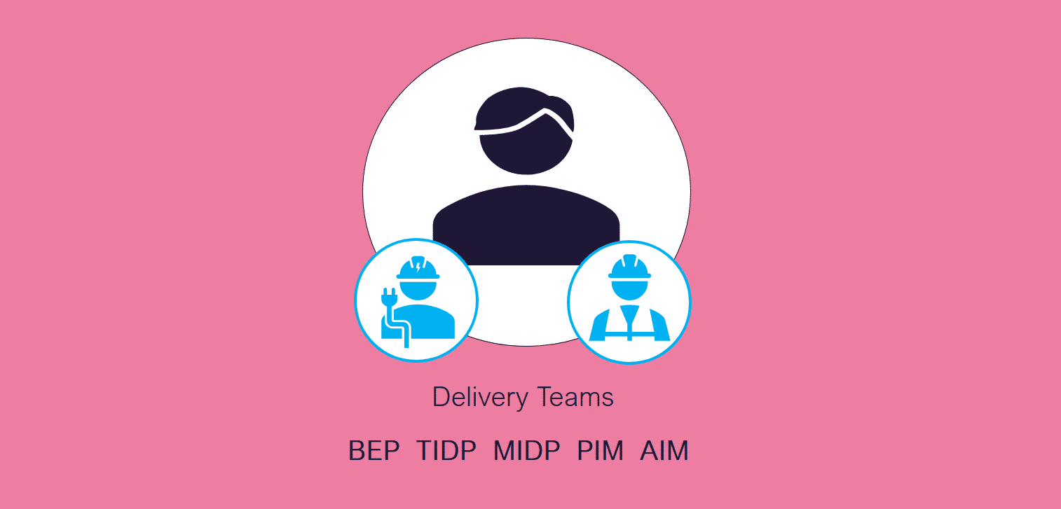
Shown here are the most common BIM terms used in relation to delivery team responsibilities:
BEP TIDP MIDP PIM AIM
We shall discuss what these mean next...

Flashcards
Card 1
BEP, BIM Execution Plan. A collaborative plan of how information should be produced, exchanged and managed on a project.
Card 2
TIDP, Task Information Delivery Plan. A schedule of deliverables to be produced by a particular task team on a project.
Card 3
MIDP, Master Information Delivery Plan. A schedule of deliverables to be produced on a project.
Card 4
PIM, Project Information Model. The information model used during a project’s delivery phase.
Card 5
AIM, Asset Information Model. The information model used during an asset’s operational phase.

Lesson Summary
Lesson complete! You are now able to:
Introduce BIM by defining the term and considering how it is used.
Understand how the term BIM is used in many different ways by many different people.
* * *
[CONTINUE]

